AI ASSISTED CODING

ROLLNO:2403A52082

BATCH-4

LAB-10.4

TASK-1:

PROMPT: Identify and fix syntax, indentation, and variable errors in the  
given script.

**buggy_code_task1.py**

def add_numbers(a, b)  
result = a + b  
return reslt  
print(add_numbers(10 20)

CORRECTED CODE:

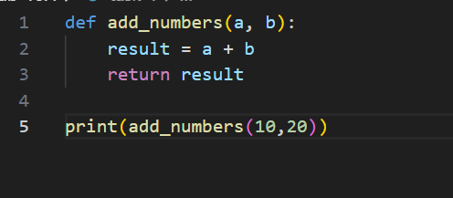

OUTPUT:

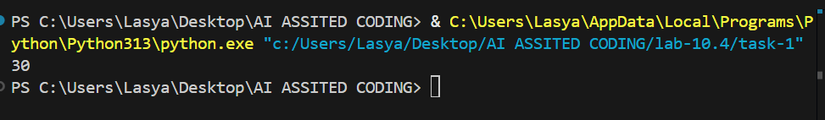

* OBSERVATION:MISSING SEMICOLON ,INDENTATION ERROR,MISSING COMA BETWEEN ARGUMENTS.

TASK-2:

PROMPT: Optimize inefficient logic while keeping the result correct.

**buggy_code_task2.py**

def find_duplicates(nums):  
duplicates = []  
for i in range(len(nums)):  
for j in range(len(nums)):  
if i != j and nums[i] == nums[j] and nums[i] not in duplicates:  
duplicates.append(nums[i])  
return duplicates  
numbers = [1,2,3,2,4,5,1,6,1,2]  
print(find_duplicates(numbers))

CORRECTED CODE: 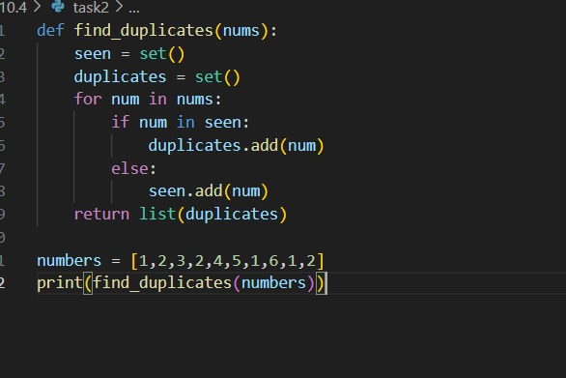

OUTPUT: 

TASK-3:

PROMPT: Refactor messy code into clean, PEP 8–compliant, well-  
structured code.  
# buggy_code_task3.py

def c(n):  
x=1  
for i in range(1,n+1):  
x=x*i  
return x  
print(c(5))

CORRECTED CODE:

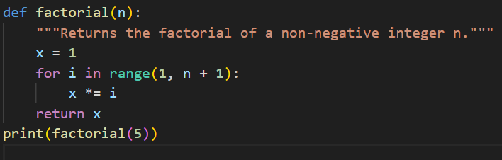

OUTPUT:

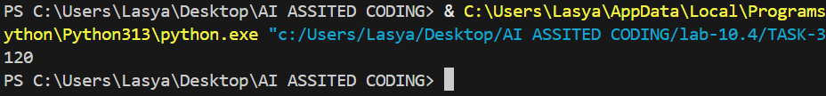

OBSERVATION: INDENTATION ERRORS,FUNCTION IS ALSO WRONG.

TASK-4:

PROMPT: Add security practices and exception handling to the code.

**buggy_code_task4.py**

import sqlite3  
def get_user_data(user_id):  
conn = sqlite3.connect("users.db")  
cursor = conn.cursor()  
query = f"SELECT * FROM users WHERE id = {user_id};" #  
Potential SQL injection risk  
cursor.execute(query)  
result = cursor.fetchall()  
conn.close()  
return result  
user_input = input("Enter user ID: ")  
print(get_user_data(user_input))

CORRECTED CODE: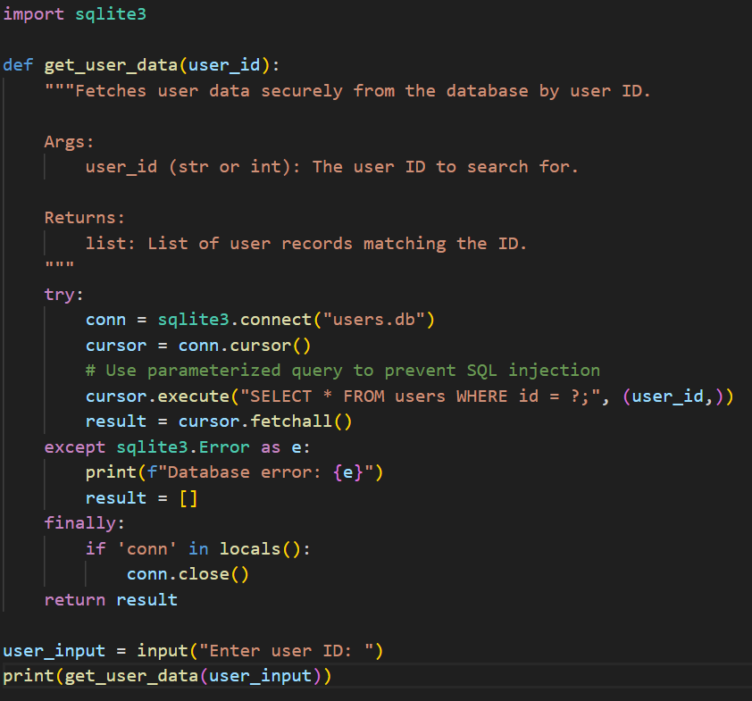

OUTPUT:

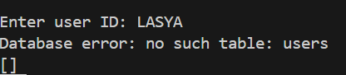

EXPLATION: This code securely fetches user data from a SQLite database using a user ID.  
It uses a parameterized query (?) to prevent SQL injection attacks.  
Exception handling ensures that database errors are caught and reported, and the connection is always closed.  
The user is prompted for an ID, and matching records are printed.

TASK-5:

PROMPT: Generate a review report for this messy code.

**buggy_code_task5.py**

def calc(x,y,z):  
if z=="add":  
return x+y  
elif z=="sub": return x-y  
elif z=="mul":  
return x*y  
elif z=="div":  
return x/y  
else: print("wrong")  
print(calc(10,5,"add"))  
print(calc(10,0,"div"))

CORRECTED CODE:

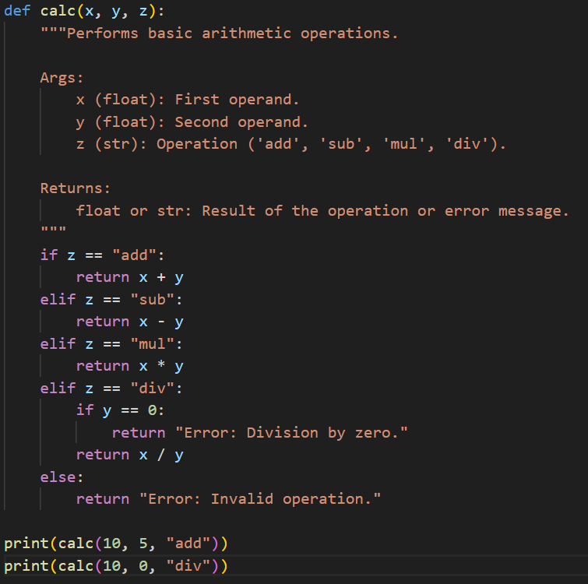

OUTPUT:



OBSERVATION:

ERRORS: INDENTATION ERROR AND FORMATTING,ERROR HANDLING,FUNCTION RETURN CONSISTENCY,CODE STRUCTURE.

SUMMARY: The function calc(x, y, z) performs basic arithmetic operations based on the value of z. The code is functional but suffers from poor formatting, lack of error handling, and inconsistent structure.

RECOMMENDATION:

* Fix indentation and formatting to comply with PEP 8.
* Add exception handling for division by zero.
* Ensure the function always returns a value.
* Replace inline prints with proper error messages or exceptions.
* Consider using a dictionary to map operations for scalability.